- Determine and list your entities. Then create relationship sentence pairs between those entities that are related. You should not have any many-to-many relationships.
Entities and their attributes
- Movie- movie title, movie ID, distributor movie ID, movie type, discount ID
- DVD- movie title, movie ID, DVD ID, distributor movie ID, distributor serial NO, purchase cost
- Video-movie title, movie ID ,video ID ,distributor movie ID, distributor serial NO, purchase cost,
- Distributors-distributor name, distributor ID, movie type, quantity of shipment, distributor serial NO, distributor movie ID.
- Customers-customer name, address, telephone number, video ID rented,DVD ID rented,
- Purchase-date of purchase, distributor ID, purchase cost
- Rent-date of rent, video ID, DVD ID, customer name
- Returns-date of return, video ID, DVD ID, customer name, return due date
- Charges-type of charge, amount,
- Discount-discount ID, discount amount, video ID, DVD ID, movie type
Relationship sentence pair
A movie can be copied to produce many videos but a video can contain a single movie.
A movie can be copied to many dvd but a dvd can contain one movie.
A customer can rent several videos but a video can be rented by a single customer.
A customer can rent several dvds but a dvd can be rented by a single customer.
A customer can be entitled to several charges such as damage fees but a charge is associated to a single customer.
A customer can return videos or dvds severally but a video or dvd can be returned by a single customer.
In a single purchase many videos can be bought but a video can only be associated with one purchase.
A purchase can be associated to a single distributor but a distributor can be associated to many purchases.
A purchase can be associated with several dvds but a dvd can only be associated to a single purchase.
A customer can rent severally but one rental service is associated with a single customer
A rental service is associated with one return service and one return service is associated with one rental service.
A return service is associated with one charges entity and a charges entuty is associated to one return service
Discount can be offered by a single distributor and a distributor can offer several discounts.

2) Create an entity/relationship diagram (ERD) showing all your entities, attributes, and relationships. Sketch your ERD by hand or use a drawing program. Your diagram must be on a single page. All entities should be related to at least one other entity. Your ERD should have all one-to-many relationships and not have any many-to-many relationships.

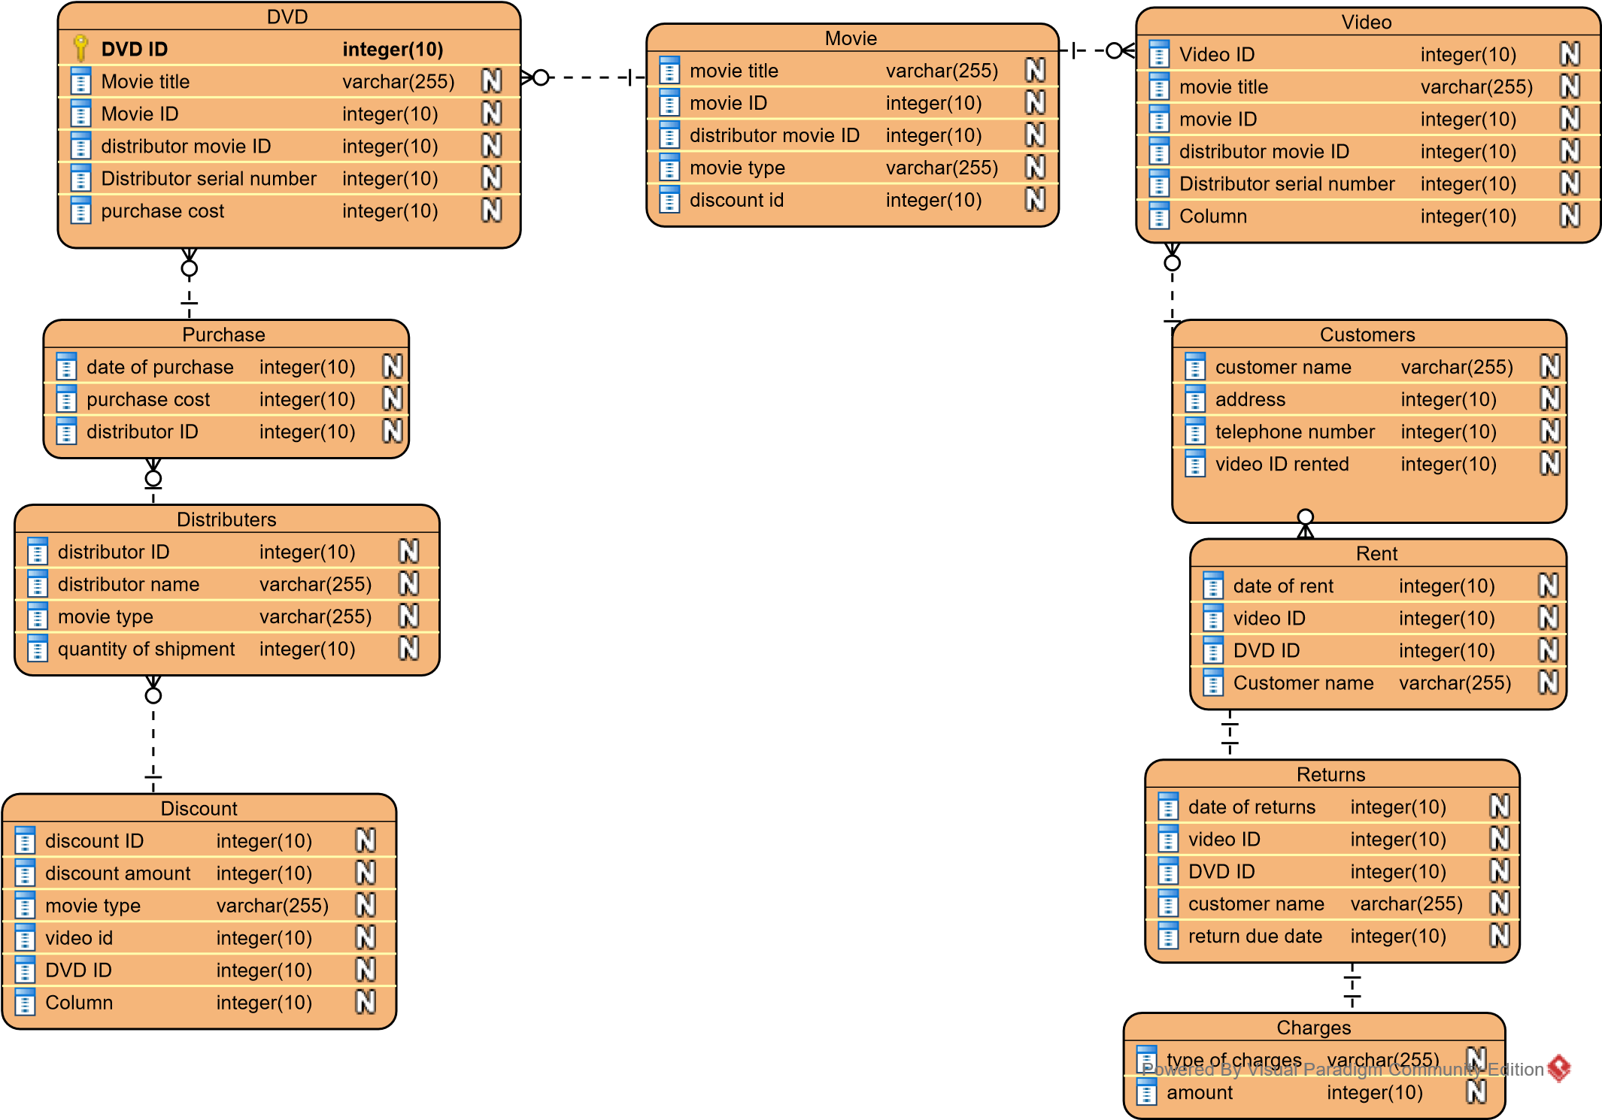
3.Create metadata that describes the table created from each entity and the column created from each attribute in the ERD. Particular attention will be given to the proper specification of all primary key (via "PK") and foreign key (via "FK") columns in the table layouts. These should match your ERD exactly.
Table movie
Movie ID | Movie title | Distributor movie ID | Movie type | Discount ID
60207 | White chicks | 22 | comedy | En-229
60208 | Gone girl | 23 | drama | En-230

Table DVD
Movie ID | Movie title | Distributor movie ID | Distributor serial NO | Purchase cost | DVD ID
60207 | White chicks | 22 | 111111/22 | 50 | 602070
60208 | Gone Girl | 23 | 111111/23 | 65 | 602072

Video ID | movie title | Movie ID | Distributor movie ID | Distributor serial no | Purchase cost
602071 | White chicks | 60207 | 22 | 111111/22 | 50
602082 | Gone girl | 60208 | 23 | 111111/23 | 65
Table video

Table Distributors
Distributor name | Distributor ID | Movie type
Jacksons limited | 01 | Comedy
Orange limited | 02 | drama

Table Customers
Customer name | address | Telephone number | Video ID rented | Dvd ID rented
Mercy | 006 westlands | +254720077098 | 602071 | 602070
fancy | 321 parklands | +254721345000 | 602082 | 602072

Table Purchase
Date of purchase | Distributor ID | Purchase cost
2/11/2017 | 01 | 50
3/11/2017 | 02 | 65

Table Rent
Date of rent | Video ID | Dvd ID | Customer name
3/11/2017 | 602071 | 602070 | Mercy
7/11/2017 | 602082 | 602072 | fancy

Table Charges.
Type of charge | Amount
Damage fees | 50
Late fees | 30

Table Returns.
Date of return | Dvd ID | Video ID | Customer name | Return due date
13/10/2017 | 602070 | 602071 | Mercy | 15/11/2017
11/11/2017 | 602082 | 602072 | fancy | 19/11/2017

Table Discount.
Discount ID | Discount amount | Video ID | DVD ID | Movie type
105 | 5 |  | 602070 | Comedy
117 | 10 | 602082 |  | Drama

